33. Develop a system using UML for Personal Loan Management System. The admin should add new customers and view the customer's records. The admin should check the defaulters. The customer can see his/her account detail and apply for a new loan by providing the required documents, and Page 5 of 6 payslip. The admin should verify the document submitted and approve the loan after verifying the payback potential of the customer.

Use Case Diagram :

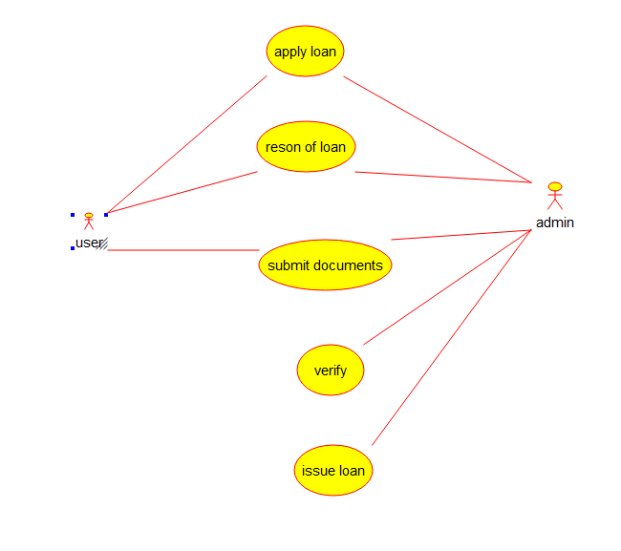

Collaboration Diagram :

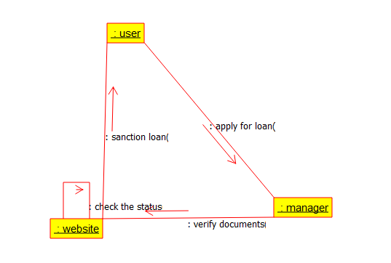

State Diagram :

